Project Design Phase
Solution Architecture

Date | 9 June 2026
Team ID | 24EG105K42
Project Name | ShopEz
Maximum Marks | 4 Marks

Solution Architecture:
Solution architecture is a complex process – with many sub-processes – that bridges the gap between business problems and technology solutions. Its goals are to:
- Find the best tech solution to solve existing business problems.
- Describe the structure, characteristics, behavior, and other aspects of the software to project stakeholders.
- Define features, development phases, and solution requirements.
- Provide specifications according to which the solution is defined, managed, and delivered.

Example - Solution Architecture Diagram:

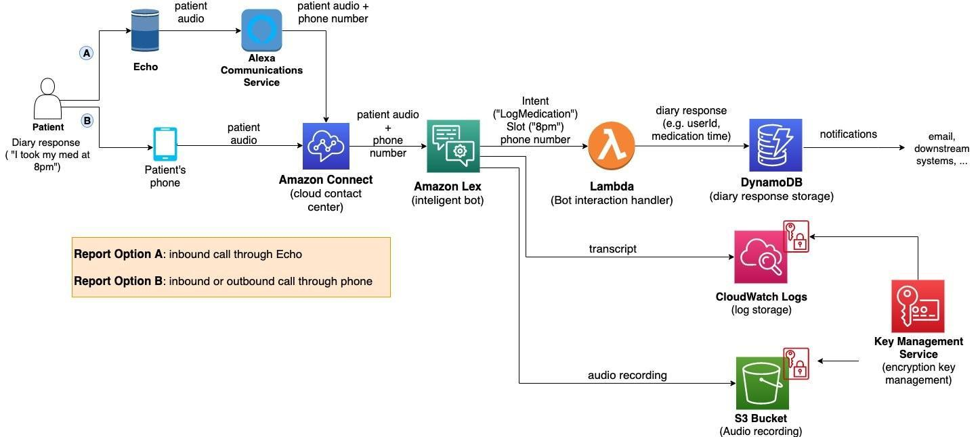
Figure 1: Architecture and data flow of the voice patient diary sample application
Reference: https://aws.amazon.com/blogs/industries/voice-applications-in-clinical-research-powered-by-ai-on-aws-part-1-architecture-and-design-considerations/

ShopEZ - Solution Architecture

Frontend (React.js)
The user interacts with the React.js frontend running on http://localhost:3000. The frontend contains pages such as Home, Login, Register, Products, Cart, Profile, and Admin Dashboard. React Router is used for navigation and Axios is used for API communication with the backend.

Backend (Node.js + Express.js)
The backend server runs on http://localhost:6001. Express.js handles API requests related to authentication, products, categories, cart management, and orders. Controllers and routes are used to organize the business logic.

Database (MongoDB)
MongoDB is used as the database for storing application data. Mongoose is used to define schemas and interact with MongoDB collections.

How they connect:
- User opens ShopEZ in the browser.
- React frontend sends API requests using Axios.
- Express server receives and processes the requests.
- MongoDB stores and retrieves the required data.
- Express sends responses back to React.
- React updates and displays the information to the user.

Collections:
Users Collection
- Username
- Email
- Password
- User Type
Products Collection
- Title
- Description
- Price
- Category
- Image URL
- Sizes
- Rating
Cart Collection
- User ID
- Product ID
- Quantity
Orders Collection
- User ID
- Product Details
- Total Amount
- Order Status
Admin Collection
- Banner Images
- Product Categories

Technologies Used
- React.js
- Node.js
- Express.js
- MongoDB
- Mongoose
- Axios
- JavaScript
- HTML
- CSS

